"You are a Solutions Architect tasked with designing a resilient and scalable deployment of a web application and MySQL database using Docker and Kubernetes. The web application is expected to experience variable loads, with potential for significant traffic spikes. The MySQL database stores critical data and must be highly available and persistent. You need to deploy mysql database as container and provide persistent volume. Please deploy below resources

1. Create persistent volume – yaml fiel screenshot

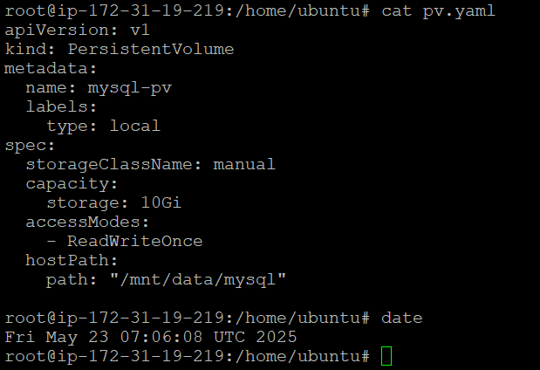

1. Create Persistent volume claim - yaml fiel screenshot

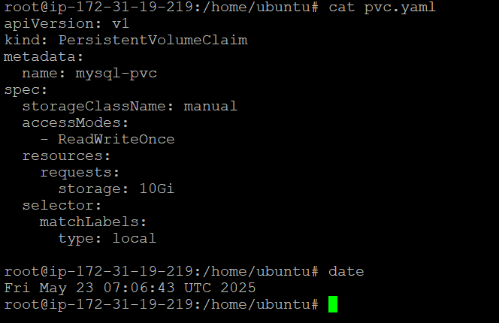

1. Mysql- single replica deployment which mounts persistent volume - yaml fiel screenshot

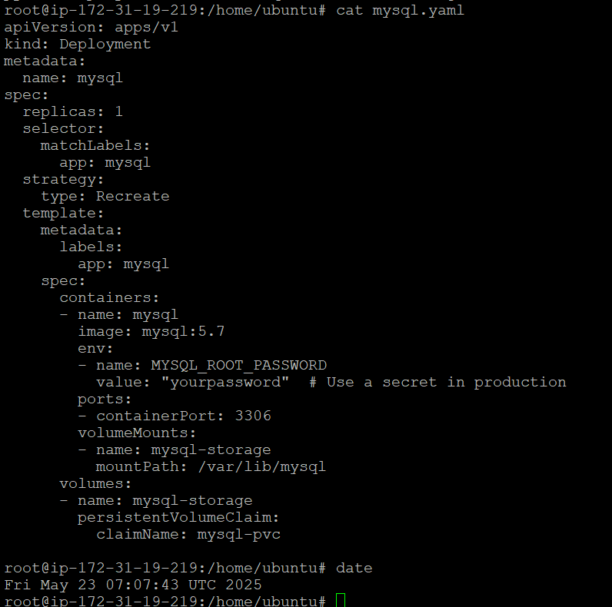

1. kubectl get pods – pod showing up

